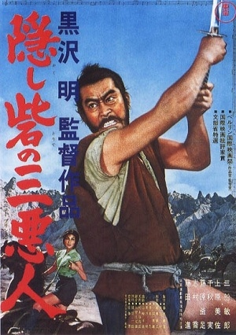A grand-scale adventure, The Hidden Fortress stars Toshiro Mifune as a general charged with guarding his defeated clan's princess as the two smuggle royal treasure across hostile territory. This film’s sidekick comedy pair was the primary influence on George Lucas's R2-D2 and C-3PO from Star Wars. The Hidden Fortress delivers Kurosawa's trademark blend humor, action, and humanity. | 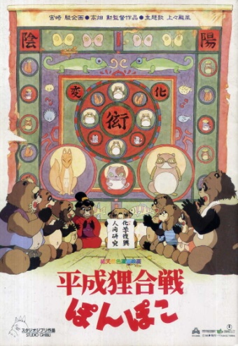Modern civilization and the natural world clash in Studio Ghibli's Pom Poko. The raccoons of the Tama Hills are being forced from their homes by the rapid development of houses and shopping malls. They decide to band together and fight back using the ancient art of transformation to appear as humans. In often hilarious ways, they try to scare off the advance of civilization. But will it be enough? Or will the raccoons learn to live in balance with the modern world?
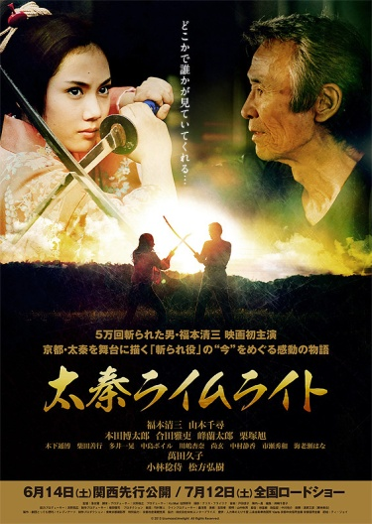In Uzumasa Limelight, Kamiyama is a veteran movie extra in chanbara (sword-fighting) movies. He has devoted 50 years of his life to the art of the kirare-yaku, one who is cut, and lives to die and show a beautiful death on screen. But suddenly his studio decides to discontinue its chanbara productions. Kamiyama finds himself at a loss, but hope arrives in the form of a young girl named Satsuki who become his disciple. Will the art of dying by the sword live on? | 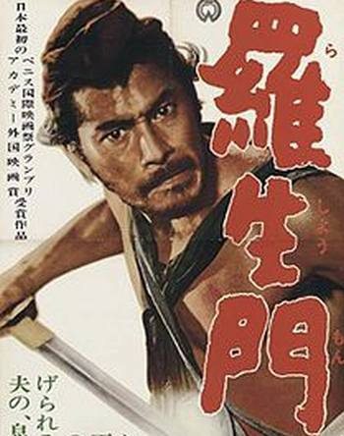In Rashomon four people give different accounts of a man's murder and the rape of his wife. Director Akira Kurosawa presents these accounts with striking imagery and ingenious use of flashback, creating an eloquent masterwork that revolutionized film language and introduced Japanese cinema -- and Toshiro Mifune -- to the Western World.

