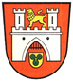

The Hannover Committee

Of the Sister City Association of Kansas City

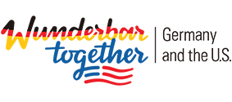
Presents the 3rd, 4th and 5th movie of a series of 7 film =====================================================================================
2019 German Film Festival
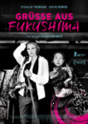
Celebrating “DeutschlandJahr 2018/19”
Kansas City Public Library@ Waldo Branch
in Waldo Room A
201 E. 75th Street, Kansas City, MO 64114
Thursday, February 21st, 2019
Doors open at 6:00 pm - Program starts at 6:30 pm
Admission: FREE - DONATIONS are appreciated!
In German Language with English subtitles
Greetings from Fukushima (Grüße aus Fukushima) 104 min.,
Marie and her husband separate on their wedding day. Now, the young woman wants to get as far away as possible from the place of the tragic event. She travels to Japan with the organisation “Clowns4Help” to help the survivors of the Fukushima catastrophe. Marie quickly realises that she can’t carry out the task. But she doesn’t want to give up. She accompanies the ageing geisha Satomi to her destroyed house in the exclusion zone, which has been radioactively contaminated since 2011. A surprising friendship slowly forms between the two very different women, from which both have a lot to gain.

Penn Valley Community College
3201 SW Trafficway, Kansas Cit9, MO, 64111
Saturday, March 9th, 2019
Doors open at 1:00 pm – Program starts at 1:30 pm
Admission: FREE - DONATIONS are appreciated !
In German Language with English subtitles – 104 min.
Goethe ! Director: Philip Stölzl, colour,
1772: The 23-year-old law student, Johann Wolfgang Goethe, flunks his oral exams. His angry father sends him to the Imperial High Court in Wetzlar. Goethe, who dreams of a career as a poet and has to digest the rejection of his play Götz von Berlichingen, falls in love with Charlotte Buff. But her father has already promised her to another man. Goethe reacts to his misfortune by writing The Sorrows of Young Werther — and overnight, the novel makes him the new star of German literature.
Thursday, March 21st, 2019
Doors open at 6:00 pm – Program starts at 6:30 pm
Admission: FREE - DONATIONS are appreciated !
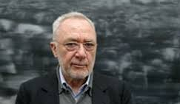
In German Language with English subtitles – 101 min.

Gerhard Richter Painting
Cont. next page
Continued: Gerhard Richter is considered one of the most important contemporary painters and “saved painting in the 21st century” (Süddeutsche Zeitung): Gerhard Richter, born in 1932 in Dresden, was trained at the Academy of Fine Arts there, and, after escaping to West Germany, at the National Academy of Arts in Düsseldorf. Since then, Richter has received numerous international awards, and his exhibitions have been celebrated around the world. The filmmaker Corinna Belz was able to observe the artist during his daily work in the studio; she documents the creative process of several paintings – up to the gallery opening in New York. With her sensitive curiosity she has created a unique documentary, far removed from all traditional portraits of artists, some of which are more academic than others.
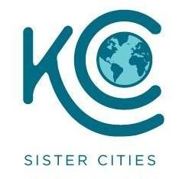
The Sister City Association of Kansas City (SCAKC) is an international citizen’s organization.
We support and promote cooperation and understanding for innovative programs in commerce, tourism, education and cultural awareness. Hannover, Germany, is represented in Kansas City by the Hannover Committee of SCAKC (www.kcsistercities.org/sistercities/hannover-germany), and
is chaired by Dr. Traute Kohler traute.kohler2@gmail.com

From now until the end of 2019, Germany will be celebrating a year of German-American friendship knowing that the United States and Germany are Wunderbar Together ― stronger as friends and partners. With this initiative,we are focusing on our robust relationship, rooted in deep historic ties, shared values, and bold visions for the future. We are also recalling how after the end of World War II, transatlantic partnership ushered in a unique era of peace, freedom, and security. For us Germans, the United States remains our closest partner outside Europe. Our friendship with the United States means a lot to us, as we know it does to many Americans. That is why people will beat the heart of this year of German-American friendship. Over the coming months, we would like to renew the dialogue with our American friends about the importance of our relationship and how we can shape it for the future. As we face shared challenges and societies become more divided, we must build more – and stronger – bridges between our peoples.
Transimpex: Doris Ganser / President, Translator Grad. doris@transimpex.com ansimpex TrTrnslators-Interpreters-Editors-Consultants Inc. donated to this good cause because offering you cultural and educational presentations like this German film festival is a truly worthwhile undertaking. Since Kansas City Sister Cities does not receive any subsidies, we hope that you, too, will be GENEROUS with your donations so that opportunities like these movies can continue Thanks in advance for joining Transimpex in donating

Acknowledgements:
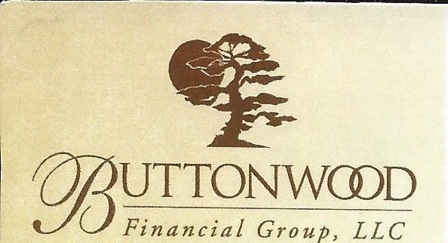
The Hannover Committee of the Sister City Association of Kansas City thanks the following companies and organizations for their continued support; We also thank the LHS for letting us use their auditorium.
TRANSIMPEX
Translation Interpreters Editors Consultants Inc
2300 Main Street St. 929, Kansas City, MO 64198

3013 Main St., K.C. MO 64108
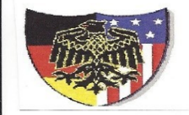
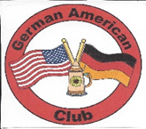
info@buttonwoodfg.com
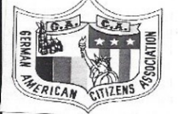
Germania Club of Kansas City
P.O. Box 2582 S.M KS 66201
Tel. 913-3818273

German American Citizen Club
mpmiller7@kc.rr.com

Shawnee German-American Club
www.shawneegermanclug.org

German Meet-up Group
www.meetup.com/KCGerman-group

Kan

